Invisi Studio: Data Visualization at your Fingertips
Dissertation submitted in fulfilment of the requirements for the Degree of
BACHELOR OF TECHNOLOGY
in
COMPUTER SCIENCE AND ENGINEERING

By
Garvit Joshi
12106692

CSE 225
ANDROID APP DEVELOPMENT


School of Computer Science and Engineering
Lovely Professional University
Phagwara, Punjab (India)
03/05/2024
Supervisor: Dr. Ranjith Kumar A

TABLE OF CONTENTS

Sl.No CONTENTS PAGE NO.

- Introduction 1
- Modules or Activity Explanation & Screenshots 2
i) User Login
ii) File Upload
iii) Chart Visualization
iv) Alarm and Other Functions
3. Emulator Screenshots 7
4. Conclusion & Future Scope 13
5. Project Github link 13

Introduction
Welcome to our innovative data visualization app! Our app is designed to empower users with the ability to seamlessly analyse, interpret, and present data in meaningful ways. Whether you’re a business professional, student, researcher, or simply curious about data trends, our app provides a user-friendly platform to explore and visualize data like never before. With a range of intuitive features and tools, users can effortlessly import data from various sources, including Excel files, and instantly transform raw data into insightful visualizations. From basic charts and graphs to advanced data maps and dashboards, our app offers a diverse array of visualization options to suit every need and preference. But our app isn’t just about visualization – it’s also about collaboration and sharing. With built-in sharing functionalities, users can easily collaborate with colleagues, classmates, or clients by sharing their visualizations via email, messaging apps, or social media platforms. Whether it’s a sales report, academic project, or research findings, our app makes it simple to communicate complex data effectively. Moreover, our app prioritizes user privacy and security. With robust data encryption and access controls, users can trust that their sensitive data always remains safe and confidential. Whether you’re working with personal, proprietary, or sensitive information, you can rest assured that your data is protected within our app’s secure environment.
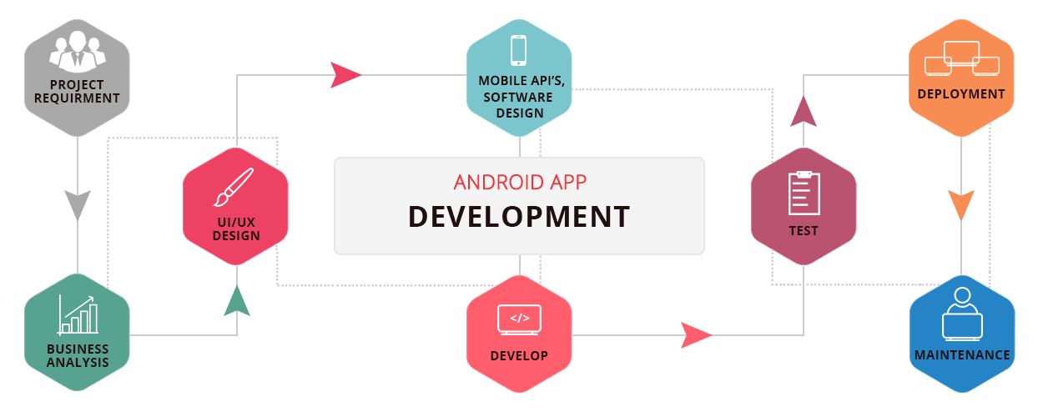

Each Component of Application
- Splash Screen:
- Engaging introduction: Display a visually appealing splash screen upon app launch to captivate users’ attention and create a memorable first impression.
- Brand identity: Incorporate branding elements such as logos, colors, and animations to reinforce brand identity and establish a cohesive visual identity.
- Loading indication: Provide visual feedback to indicate that the app is loading, reassuring users that the app is actively working.
- Login Page:
- User authentication: Implement a secure login page where users can enter their credentials (username and password) to access the app’s features and functionalities.
- Error handling: Validate user input and provide informative error messages to guide users in case of incorrect or incomplete login details.
- Remember me: Optionally include a “Remember Me” feature to allow users to save their login credentials for convenient future access.
- Chart’s View: Line Chart, Bar Chart, Pie Chart:
- Data visualization: Utilize popular charting libraries such as MPAndroidChart or AnyChart to create visually appealing line charts, bar charts, and pie charts.
- Data representation: Present data in a clear and concise manner, allowing users to easily interpret trends, comparisons, and distributions.
- Interactive features: Incorporate interactive elements such as zooming, panning, and tapping to enable users to explore and interact with the charts dynamically.
- Bottom Navigation:
- Navigation structure: Implement a bottom navigation bar to provide intuitive access to different sections or features of the app.
- Tabbed layout: Organize app content into distinct tabs within the bottom navigation bar, making it easy for users to navigate between different screens.
- Visual feedback: Provide visual indicators to highlight the currently selected tab and indicate user actions (e.g., tapping, swiping).

- View Pager:
- Swipe navigation: Integrate a ViewPager to enable horizontal swiping gestures for navigating between multiple fragments or screens within a single activity.
- Seamless transitions: Ensure smooth transitions between ViewPager pages, enhancing the overall user experience and perceived performance.
- Dynamic content: Populate the ViewPager with dynamic content, such as charts, data visualizations, or informational pages, based on user preferences or input.
- Fragments:
- Modular design: Utilize fragments to create modular, reusable components that can be combined and arranged to construct flexible and adaptable UI layouts.
- Lifecycle management: Implement lifecycle-aware behavior within fragments to handle state changes, configuration changes, and interactions with the parent activity.
- Fragment transactions: Dynamically add, remove, or replace fragments within the activity’s layout container to support navigation and content updates.
7. Internal Storage for Username and Password:
- Secure storage: Store user credentials (username and password) securely in internal storage using SharedPreferences or encrypted databases to protect sensitive information.
- Persistent data: Ensure that user login details persist across app sessions, allowing users to stay logged in without having to re-enter their credentials repeatedly.
- Data access: Implement mechanisms to securely retrieve, update, and delete user credentials as needed, following best practices for data security and privacy.
8. External Storage for Excel File Import:
- File picker: Integrate a file picker functionality to allow users to select Excel files from their device’s external storage (e.g., SD card, Downloads folder).
- File handling: Implement file handling logic to read selected Excel files from external storage and process the data for visualization or analysis within the app.
- Permissions: Request appropriate permissions (e.g., READ_EXTERNAL_STORAGE) to access files stored in the device’s external storage, ensuring compliance with platform security requirements.
9. Alarm Manager:
- Alarm scheduling: Utilize the AlarmManager class to schedule and manage alarms, allowing users to set reminders, notifications, or scheduled tasks within the app.
- Time-based triggers: Configure alarms to trigger at specific times or intervals, providing users with timely alerts and notifications for important events or tasks.
- Background execution: Ensure that alarm-related tasks are executed efficiently in the background, minimizing impact on system resources and battery life.
10. Side Bar in the Top App Bar:
- Navigation drawer: Implement a side navigation drawer within the top app bar to provide access to app navigation, settings, or additional functionality.
- Hamburger menu: Include a hamburger icon or swipe gesture to toggle the visibility of the side navigation drawer, offering a convenient way for users to access hidden content.
- Customization options: Allow users to customize the contents of the side navigation drawer, such as adding shortcuts, bookmarks, or personal preferences, to enhance usability and personalization.

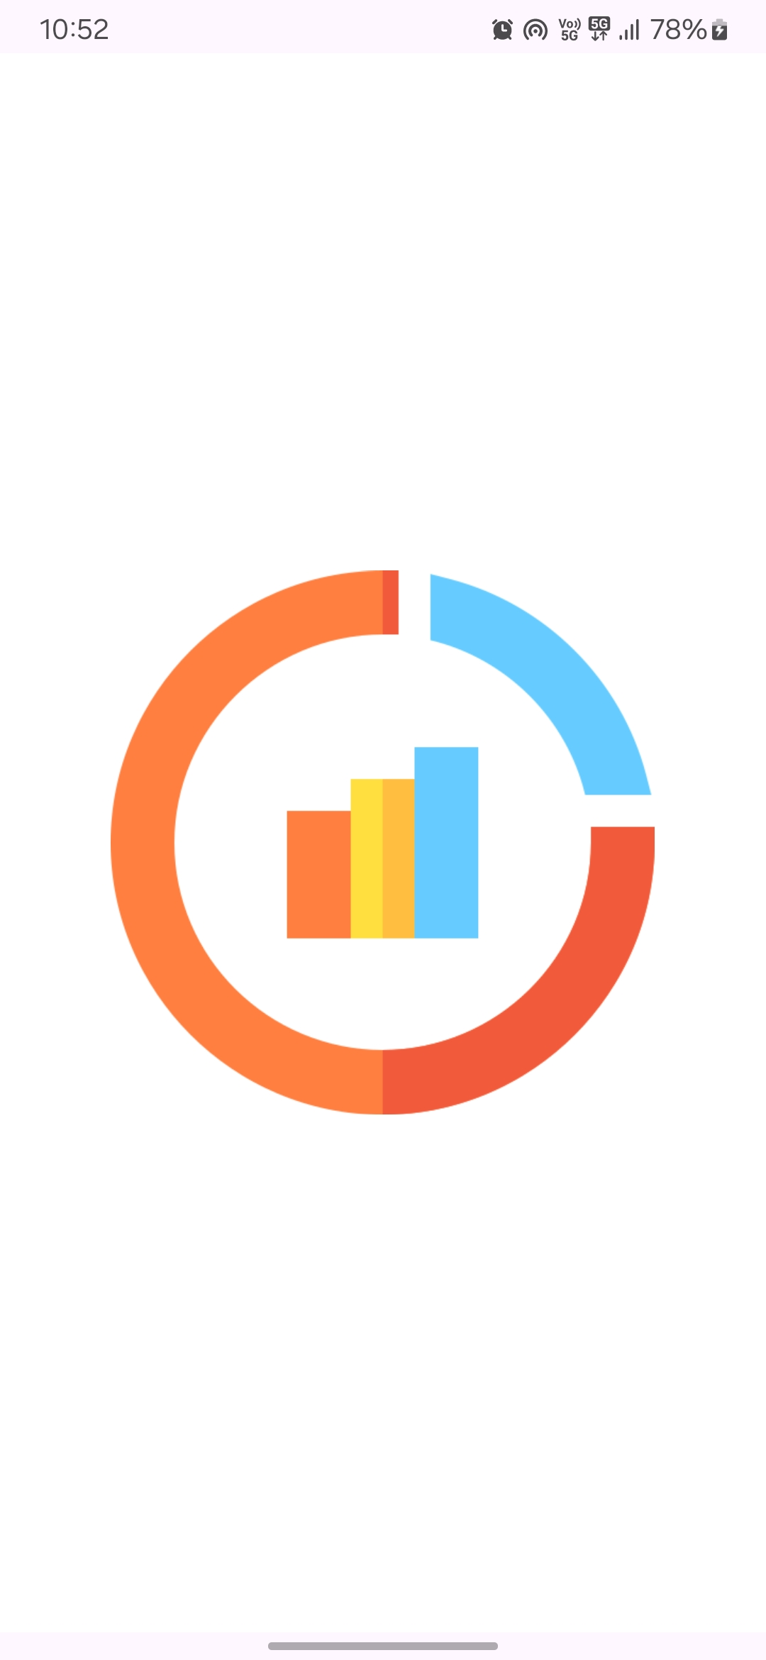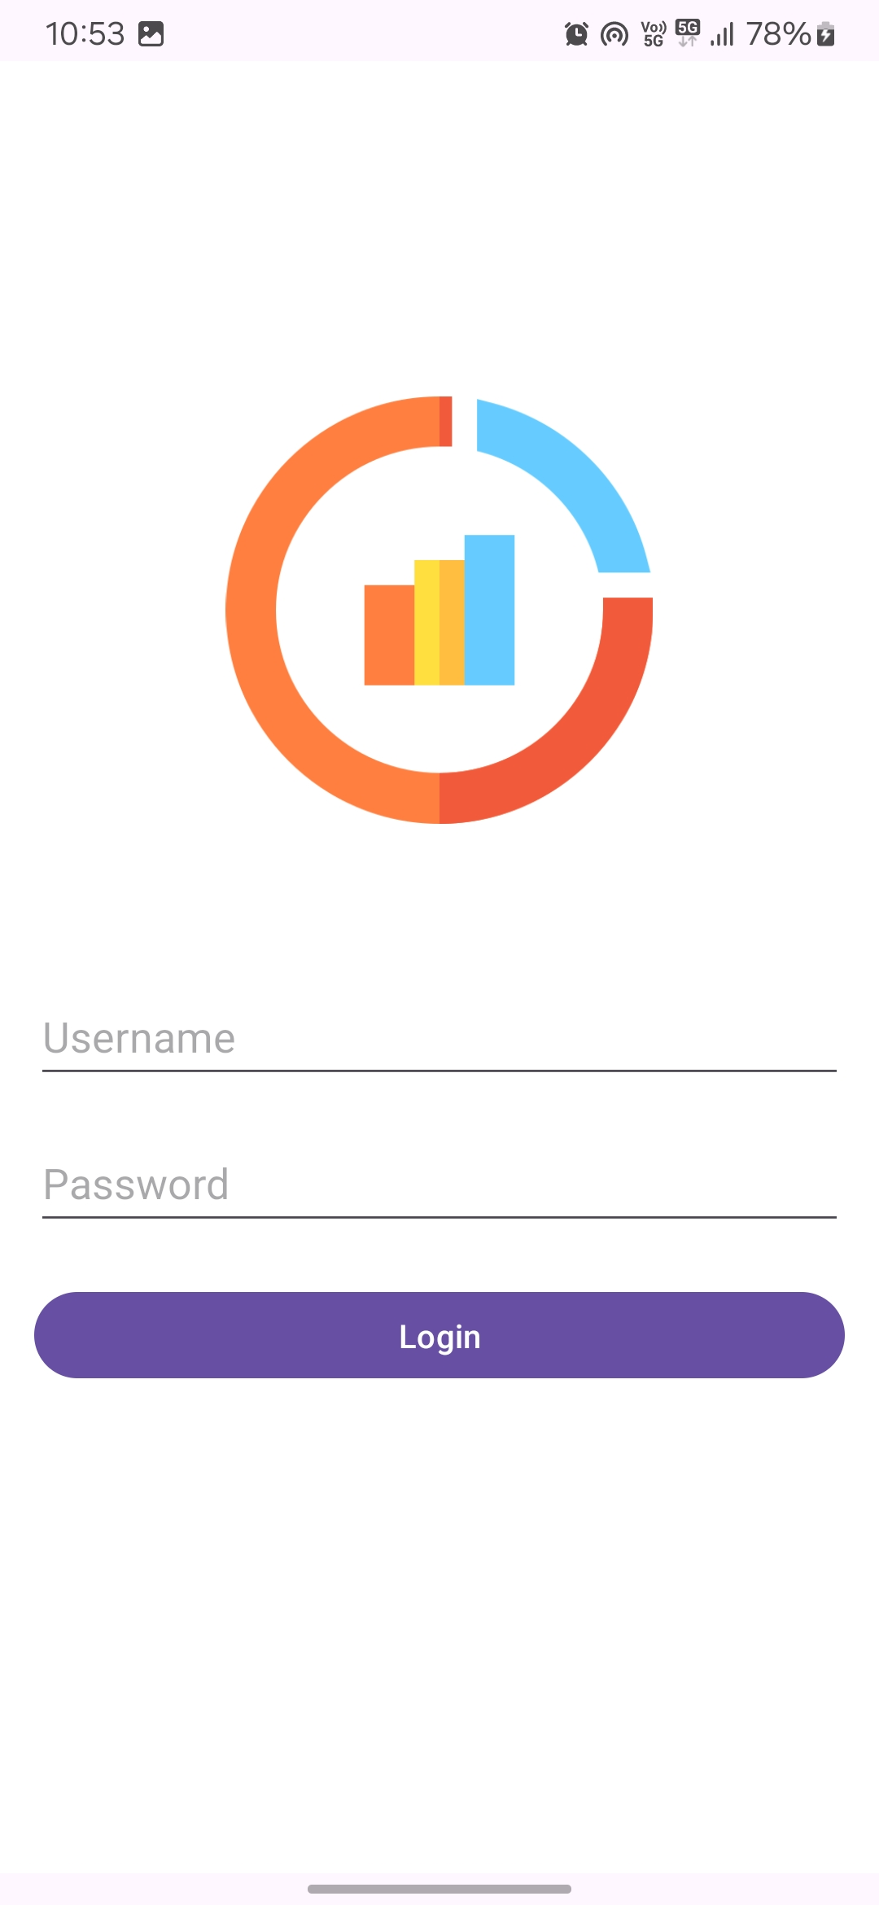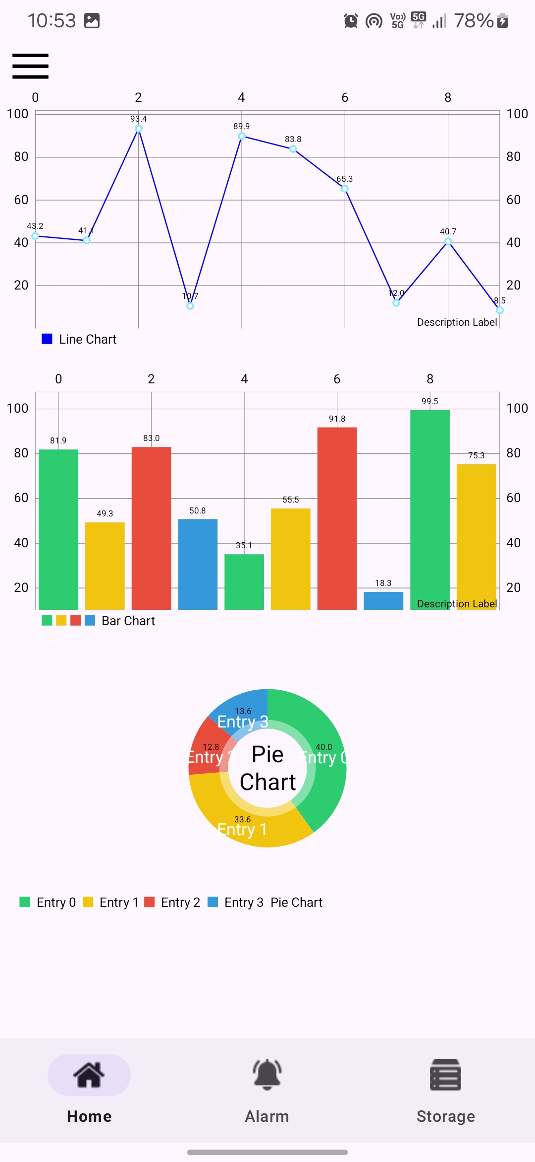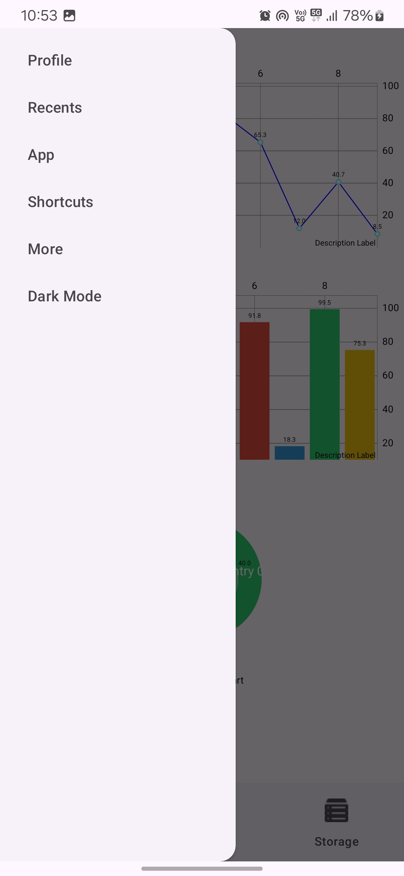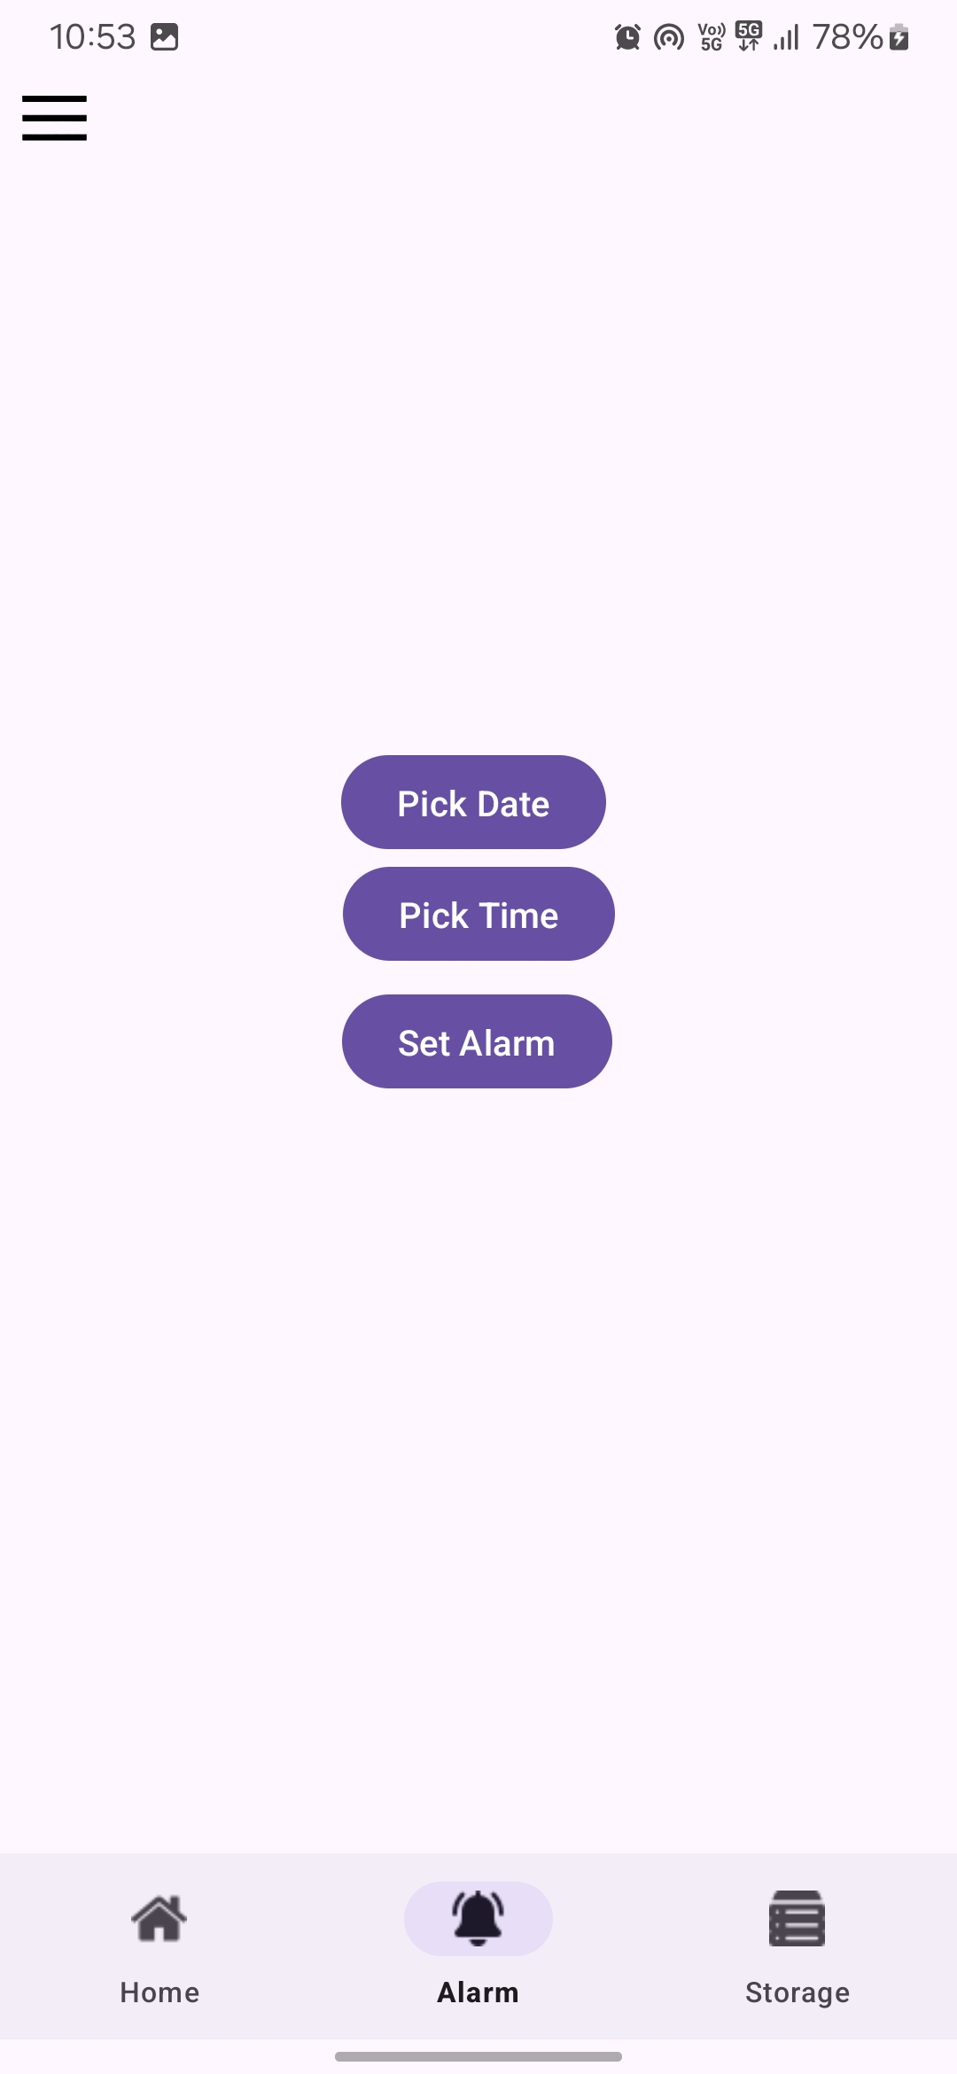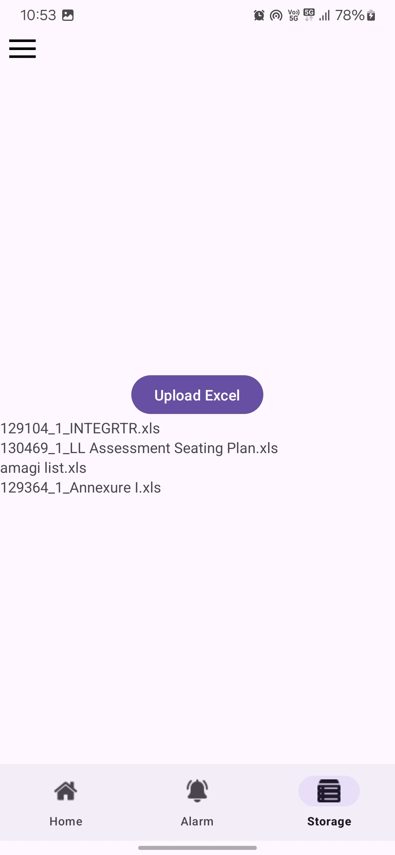
Conclusion and Future Scope
In conclusion, the app represents a cohesive amalgamation of diverse functionalities and features meticulously designed to offer users an immersive and seamless experience. From the visually captivating splash screen to the intuitively crafted login page, dynamic chart views, efficient navigation mechanisms, and robust data storage solutions, each element has been meticulously curated to cater to the users' evolving needs and expectations. Leveraging modern Android development methodologies and best practices, the app ensures a fluid user journey, facilitating effortless access to information, data visualization tools, and essential utilities. The integration of advanced features such as alarm management and external file import further enriches the app's versatility and utility, catering to a broad spectrum of user requirements and scenarios. As a testament to thoughtful design and user-centric approach, the app serves as a compelling solution for users seeking efficient data visualization, secure authentication, and intuitive navigation in the mobile ecosystem. Looking ahead, there are numerous opportunities for enhancing the app's functionality and extending its capabilities to align with emerging user demands and technological advancements. These include enhancing data visualization capabilities with additional chart types and interactive features, implementing advanced authentication mechanisms like biometric authentication and two-factor authentication, integrating cloud-based data synchronization for seamless cross-device access, introducing personalization features for tailored user experiences, developing offline mode support for uninterrupted usage, optimizing performance for enhanced user experience, and fostering a vibrant developer community for innovation and collaboration. Through continuous evolution and refinement, the app is poised to become an indispensable tool for users, empowering them to achieve their objectives efficiently and effectively in today's dynamic mobile landscape.

Project Link: https://github.com/Garvitjoshi1/Invisi_Studio

